Notes:

* Set up instructions may differ slightly depending on your project- these instructions were written for mayflower-blocks setup.
* You will need: npm/node js installed and/or updated to latest stable version
* This walkthrough assumes you already have set-up/have knowledge of: navigating file structures with command prompt/git bash, repositories (repos), [ssh-keys](https://docs.github.com/en/authentication/connecting-to-github-with-ssh/generating-a-new-ssh-key-and-adding-it-to-the-ssh-agent#adding-your-ssh-key-to-the-ssh-agent), [github](https://docs.github.com/en/get-started/quickstart/hello-world), and [git cloning](https://www.atlassian.com/git/tutorials/setting-up-a-repository/git-clone) If you are unfamiliar with any of these ask for assistance from your team or supervisor!

**Walkthrough**

1. Download [Local by Flywheel](https://localwp.com/)
2. Once you have installed Local open it up
3. Selected “create a new site”
4. New your site, I like to name it after the project I’m working on.
5. On the next screen select ‘preferred’
   1. Only select custom if you want/need to play with the php version, web server, or DB
6. This username and password is what you will use to sign in to your wordpress admin dashboard. So pick something you will remember or use a password manager!
   1. Do not change email field
   2. Advanced options allow you to toggle to a multisite if needed.
7. Your site will now be built and located in/under the local sites tab.
   1. Overview section = quick settings
   2. Database= displays database info
   3. Tools = shows optional additional tools

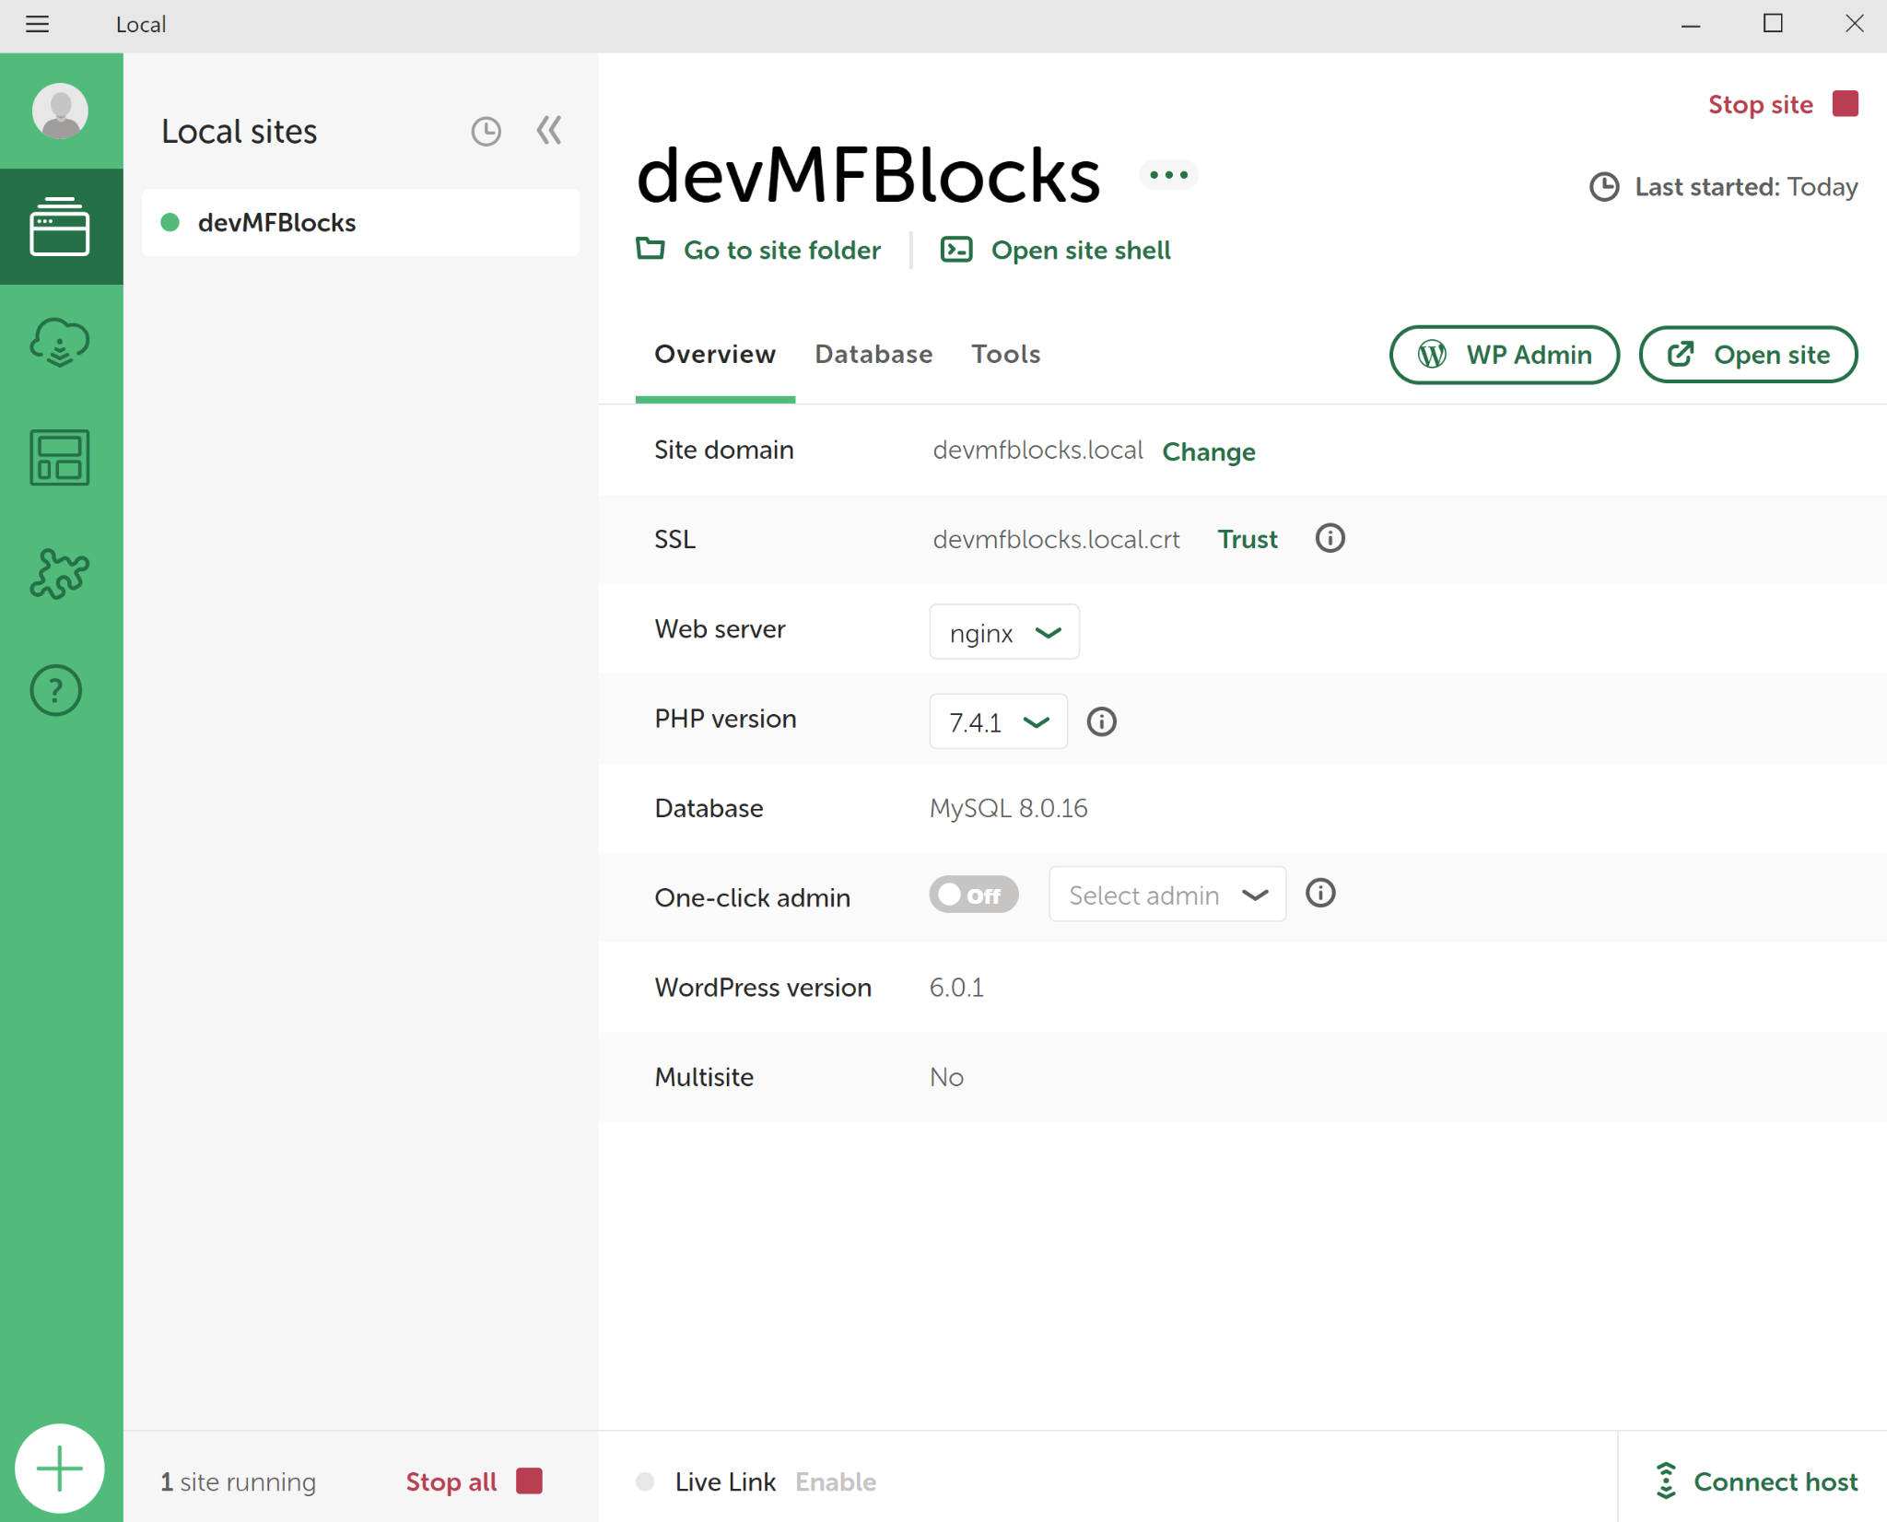

1. Start/stop site will make your website accessible locally
   1. open site will take you to your local environment site url from the front end
   2. Wpadmin will take you to your environment site from the admin/ back end
2. Git Clone the repositories needed for your github project (see links for mayflower block set-up below)
   1. [Globals](https://github.com/BellevueCollege/globals)
   2. [Mayflower-G4](https://github.com/BellevueCollege/mayflower-g4)
   3. [Mayflower-blocks](https://github.com/BellevueCollege/mayflower-blocks)
3. Find your path to your local environment files
   1. Shortcut to this folder in the GUI is to open up local, select your site, then click ‘go to folder’ ; right click the path and select ‘copy’ address

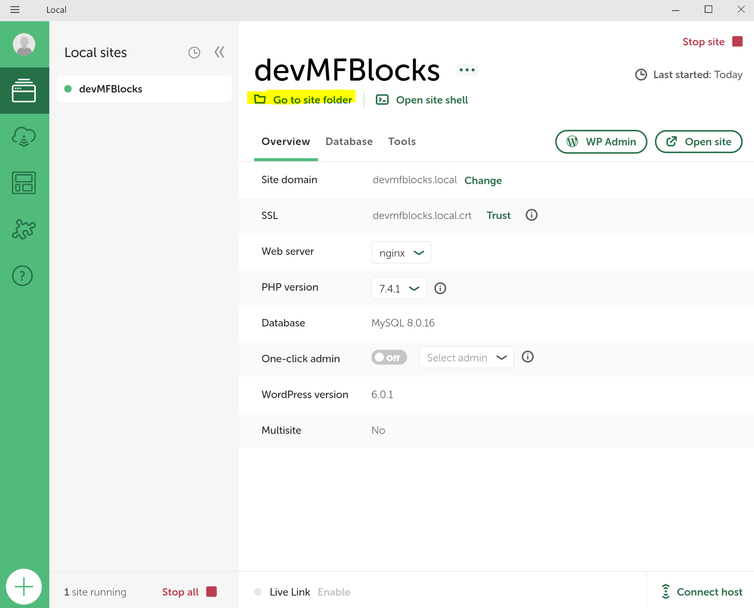

1. Open your command prompt or gitbash and navigate to the address you copied by typing ‘cd‘, and right clicking to paste the path/address from the previous step.
2. For mayflower-block we will be creating 3 symbolic links/ [mklinks](https://www.educative.io/answers/mklink-windows-10) from our local site to your theme (mayflower-G4) repo, your plugin (mayflower-blocks)repo, and your globals repo.
   * + Once in your local sites folder navigate to: app > public. This is where you will put your globals mklink
     + After that navigate to app>public>wp-content
       - From here navigate into plugins to place the mklink for mayflower-blocks
       - From here navigate into themes to place the lmklink for mayflower-G4
3. After you have set up all your mklinks navigate to the location of your globals repository in command prompt/ git bash
   1. Follow the developer set up notes [here](https://github.com/BellevueCollege/globals)
      * Make sure to navigate into src\4 and run gulp dev!
      * Run gulp dev anytime a change is made
4. Navigate to the location on your mayflower-blocks repository and into the blocks folder
   1. Once here you will need to navigate into each individual block (alerts, lead, button,etc.) folder and do two commands: npm install, npm run build (in that order!)
   2. When making changes to a specific block- navigate into that block and do the command: npm run start to see changes/ have them applied anytime you refresh.
5. If you are creating a new block, copy the BLOCK_TEMPLATE folder and paste into the blocks folder- rename it to your block name, and change name and description in package json folder from ‘button’ to your blocks name.
6. You are all set to start developing!